Physics 30 Lesson 9

Optics – Thin Lenses

Refer to Pearson pages 677 to 681.

A study of lenses is very similar to that of curved mirrors. However, while mirrors involve reflection, lenses involve refraction. In fact, for lenses there are two refractions – one when the light ray enters the lens and one when the light ray exits the lens.

Refraction 1

Using the law of refraction can you explain refraction 1 and refraction 2?

Refraction 2

Convex lens

Note that for a convex lens like the one depicted above the light ray is bent toward the principle axis twice, while for a concave lens the light ray is bent away from the principle axis.

Using the law of refraction can you explain the refractions for a diverging lens?

Concave lens

Convex lenses are converging lenses, and concave lenses are diverging lenses.

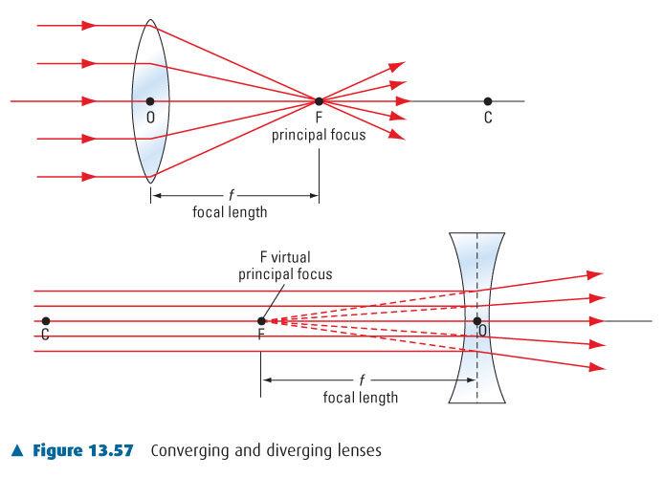

The equations used for calculating the position of an image from a lens are identical to the equations for mirrors.

where

*f* focal length – real (+), virtual (–)

*do* distance from lens to the object

*di* distance from the lens to the image – real (+), virtual (–)

*ho* height of object

*hi* height of image – real (–), virtual (+)

*m* magnification – real, inverted (–), virtual, upright (+)



While the equations for curved mirrors and thin lenses are the same, it is important to note that real images form in front of a mirror and real images form behind a lens. This is due to the fact that mirrors reflect light back while lenses refract light through to the other side of the lens.

# Images created by lenses (ray diagrams)

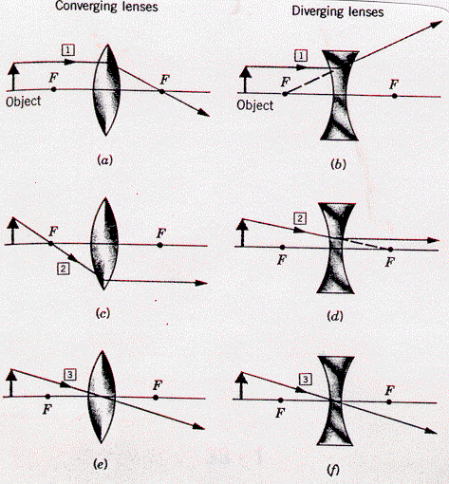

Ray 1 travels from the object parallel to the principal axis. In passing through the lens, the ray is refracted to the *real* focal point on the other side of the lens.

Ray 1 travels from the object parallel to the principal axis. In passing through the lens, the ray is refracted away from the *virtual* focal point of the lens.

Ray 2 travels through the virtual focal point and is then refracted by the lens to emerge parallel to the principal axis.

Ray 2 travels from the object toward the *real* focal point. It then emerges parallel to the principal axis.

Ray 3 travels through the centre of the thin lens straight through.

Ray 3 travels through the centre of the thin lens straight through.

The diagrams below illustrate the basic ray diagrams for objects at different positions relative to the lens.

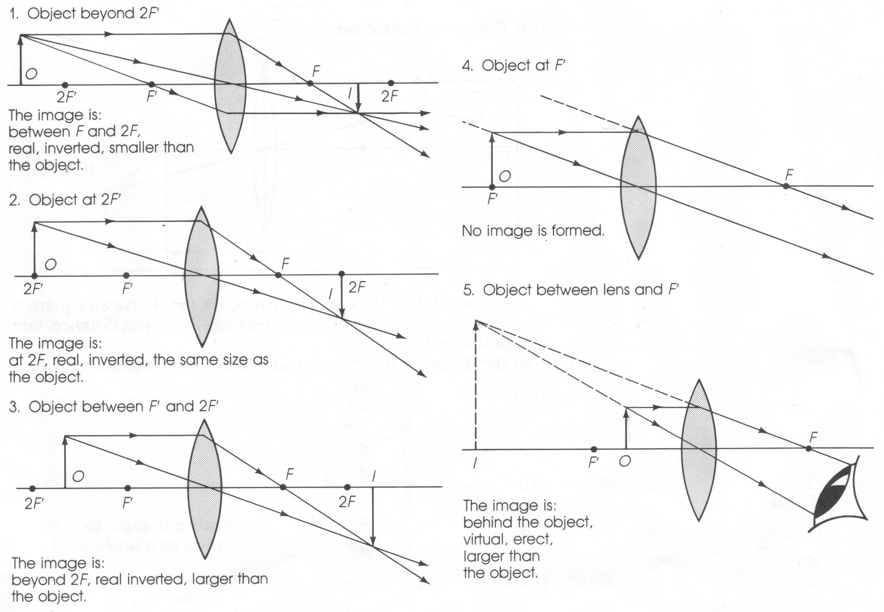

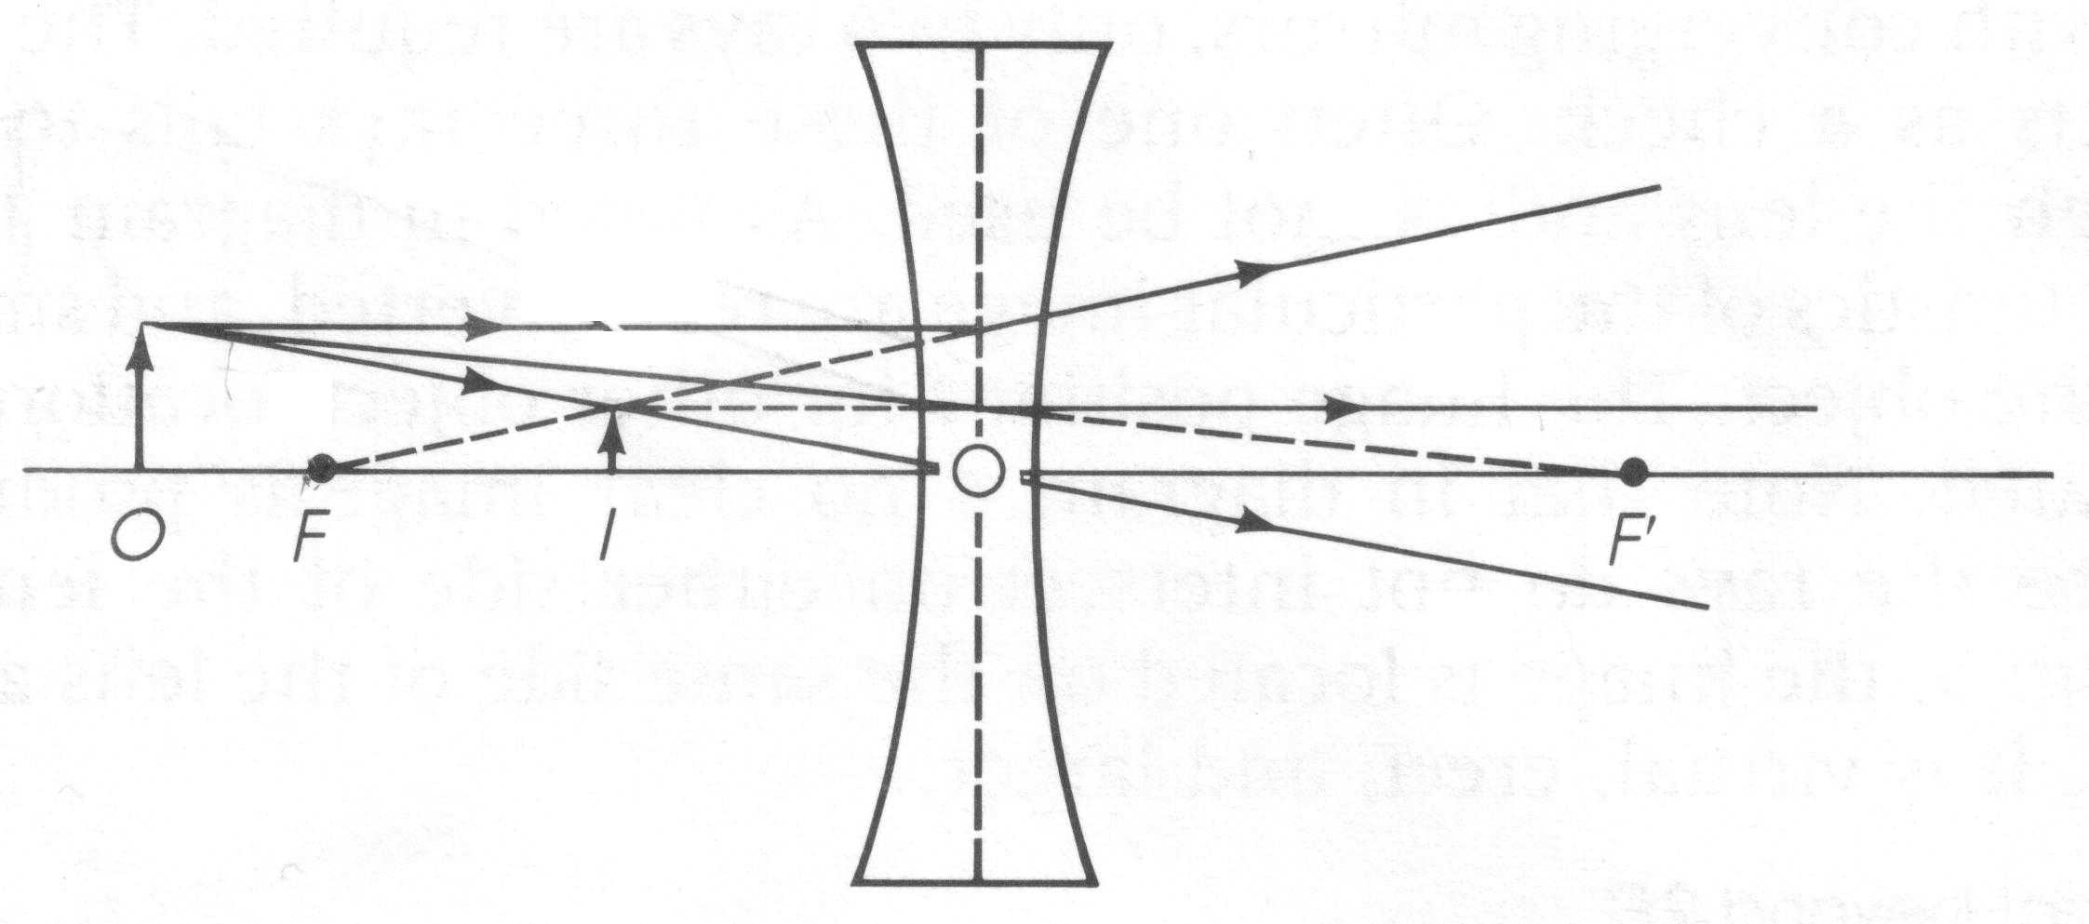

image formed from a diverging lens

Utilising the rays for lenses, complete the ray diagram for the lens below and describe the image.

•

•

2f

f

•

•

f

2f

solution

•

•

2f

f

•

•

f

2f

image is inverted, real and diminished

Image Formation – Converging Lens

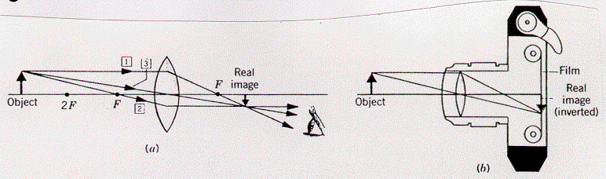

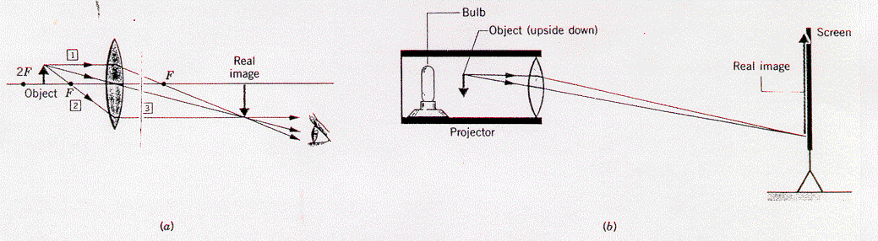

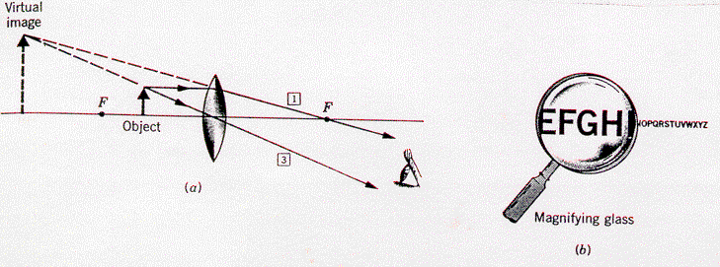

Image Formation – Diverging Lens

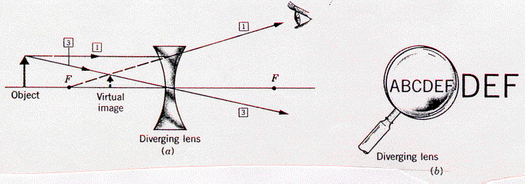

# Calculations using the lens equations

A 4.0 cm tall object is placed 50 cm away from a convex lens that has a focal length of 20 cm. Describe the image formed.

ho = 4.0 cm





 = **+33.3 cm**



= **– 2.67 cm**

do = 50 cm

f = +20 cm

convex, converging

lens

The (+) di means that the image is **real** and **inverted**.

The image is 2.67 cm tall, i.e. **diminished**.

A 5.0 cm tall object is placed 60 cm away from a diverging lens that has a focal length of 40 cm. Describe the image formed.

ho = 5.0 cm





 = **–24 cm**



= **+ 2 cm**

diverging lens

do = 60 cm

f = – 40 cm

The (–) di means that the image is **virtual**, **erect** and **diminished**.

An experiment is done where an optical device, either a mirror or a lens, is used. When the object is placed 20 cm from the optical device, an erect image of the object is found on the opposite side of the optical device. The image is one-quarter the size of the object. What kind of optical device is it and what is its focal length?

The image is erect (i.e. virtual), smaller (i.e. di is less than do) and it is on the opposite side from the object (i.e. virtual and on other side happens for mirrors only). The only way this can happen is with a **convex** (diverging) **mirror**.



= -0.15

 = **– 6.67 cm**

di is (–) for an erect image

= –5.0 cm

# Practice problems

a. (real, inverted, smaller)

•

•

2f

f

•

•

f

2f

b. (real, inverted, same size)

•

•

2f

f

•

•

f

2f

c. (real, inverted, larger)

•

•

2f

f

•

•

f

2f

d. (no image forms)

•

•

2f

f

•

•

f

2f

e. (virtual, erect, larger)

•

•

2f

f

•

•

f

2f

f. (virtual, erect, smaller)

•

f

•

f

# Hand-in assignment

1. Complete the diagrams below by drawing in the light rays as they emerge from the lenses. Label each of the lenses below as either convex or concave. Label each of the lenses below as either converging or diverging.

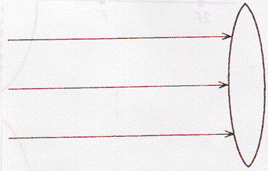 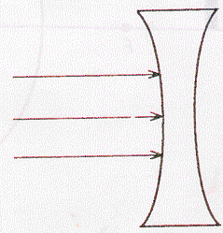

2. Using the “rules for light rays” sketch ray diagrams for the following cases. State whether the image is: Real or virtual, erect or inverted, and larger or smaller than the object.

a.

•

•

2f

f

•

•

f

2f

b.

•

•

2f

f

•

•

f

2f

c.

•

•

2f

f

•

•

f

2f

d.

•

•

2f

f

•

•

f

2f

e.

•

•

2f

f

•

•

f

2f

f.

•

f

•

f

3. An object 8.0 cm high is placed 80 cm in front of a converging lens of focal length 25 cm. Determine the image position and its height. (36 cm, –3.6 cm)

4. A lamp 10 cm high is placed 60 cm in front of a diverging lens of focal length 20 cm. Calculate the image position and the height of the image. (–15 cm, 2.5 cm)

5. A typical single lens reflex (SLR) camera has a converging lens with a focal length of 50.0 mm. What is the position and size of the image of a 25 cm candle located 1.0 m from the lens? (5.3 cm, –1.3 cm)

6. A converging lens with a focal length of 20 cm is used to create an image of the sun on a paper screen. How far from the lens must the paper be placed to produce a clear image? (20 cm)

7. The focal length of a slide projector's converging lens is 10.0 cm.

(a) If a 35 mm slide is positioned 10.2 cm from the lens, how far away must the screen be placed to create a clear image? (5.10 m)

(b) If the height of a dog on the slide film is 12.5 mm, how tall will the dog's image on the screen be? (–62.5 cm)

(c) If the screen is then removed to a point 15 m from the lens, by how much will the separation between film and lens have to change from part (a)? (0.13 cm)

8. A lens has a focal length of + 20 cm and a magnification of 4. How far apart are the object and the image? (125 cm)

9. A projector is required to make a real image, 0.50 m tall, of a 5.0 cm object placed on a slide. Within the projector, the object is to be placed 10.0 cm from the lens. What must be the focal length of the lens? (9.1 cm)

10. An object 5.0 cm high is placed at the 20 cm mark on a metre stick optical bench. A converging lens with a focal length of 20 cm is mounted at the 50 cm mark. What are the position and size of the image relative to the metre stick? (110 cm, –10 cm)

11. A camera lens has a focal length of 6.0 cm and is located 7.0 cm from the film. How far from the lens is the object positioned if a clear image has been produced on the film? (42 cm)

Activity – Convex lens

**Purpose**:

To determine the focal length of a double convex lens.

**Apparatus**:

Set up your own apparatus based on the diagram below. Be sure to return all materials to their appropriate places after you have completed the lab.

do

light source

lens

meter sticks

90

80

70

60

50

30

20

10

stand

10

20

30

40

50

70

80

90

60

**Theory**:

The thin lens equation is: 

Therefore, if we measure the object distance and the image distance we can determine the focal length of the lens.

**Procedure**:

1. Place the object at some point away from the lens. (Start at around 60 cm.) Record the object distance (distance from lens to object).

2. Using a white piece of paper as a screen, move the screen until a sharp image of the object (the bulb filament) appears on the screen. Record the image distance (distance from lens to the screen).

3. Repeat steps one and two until a total of three different positions have been located.

**Observations**:

Create an appropriate data table to organise your results.

**Analysis**:

1. Calculate the focal length for each position and then find an average result. Show all work and calculations.

2. Draw scale ray diagrams for each position showing the formation of each image.